|  |  |  |  |
| --- | --- | --- | --- |
|  | |  |  | | --- | --- | | EGC_Black | **Eastern Goldfields College**  ***Year 12 MATHEMATICS SPECIALIST***  ***TEST 2 2017***  ***Calculator Free*** | |

**Total Marks: 34**

**Reading: 2 minutes Time Allowed: 35 minutes**

**Question 1 [3, 3, 2, 2, 3 - 13 marks]**

(a) Simplify .

(b) Shade $\left\{z:1<\left|z-i\right|≤2∩0≤\arg\left(z\right)≤\frac{π}{2}\right\}$ on the set of axes below.

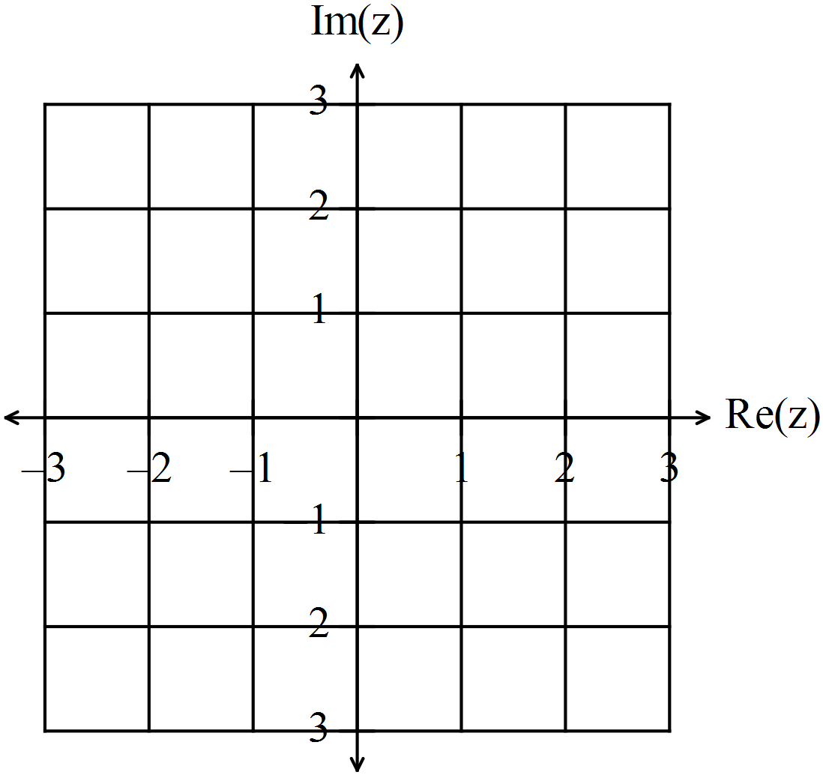

**Question 1 continued**

(c) Simplify 

(d) Find 

(e) If 

Find and give answers in Cartesian form

(i) 

(ii) 

(iii) 

**Question 2 [3, 2, 2, 2 - 9 marks]**

1. If  find the values of  and , where  and are real constants.

1. The complex number  is transformed to its reciprocal .
2. What is the reciprocal of  in the form ?
3. State the reciprocal of  in polar form.
4. Given *z* is a complex number, express the modulus and argument of  in terms of  and .

**Question 3 [5 marks]**

Use the fact that the polynomial 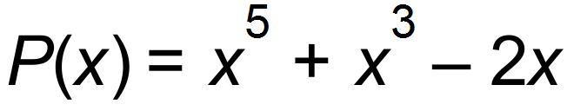 is divisible by 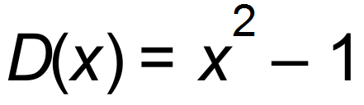, to find all real and

complex numbers that satisfy the equation:

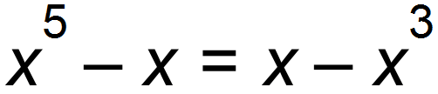

**Question 4 [2, 2, 3 - 7 marks]**

*The diagram below shows one of the solutions to the equation 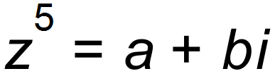.*

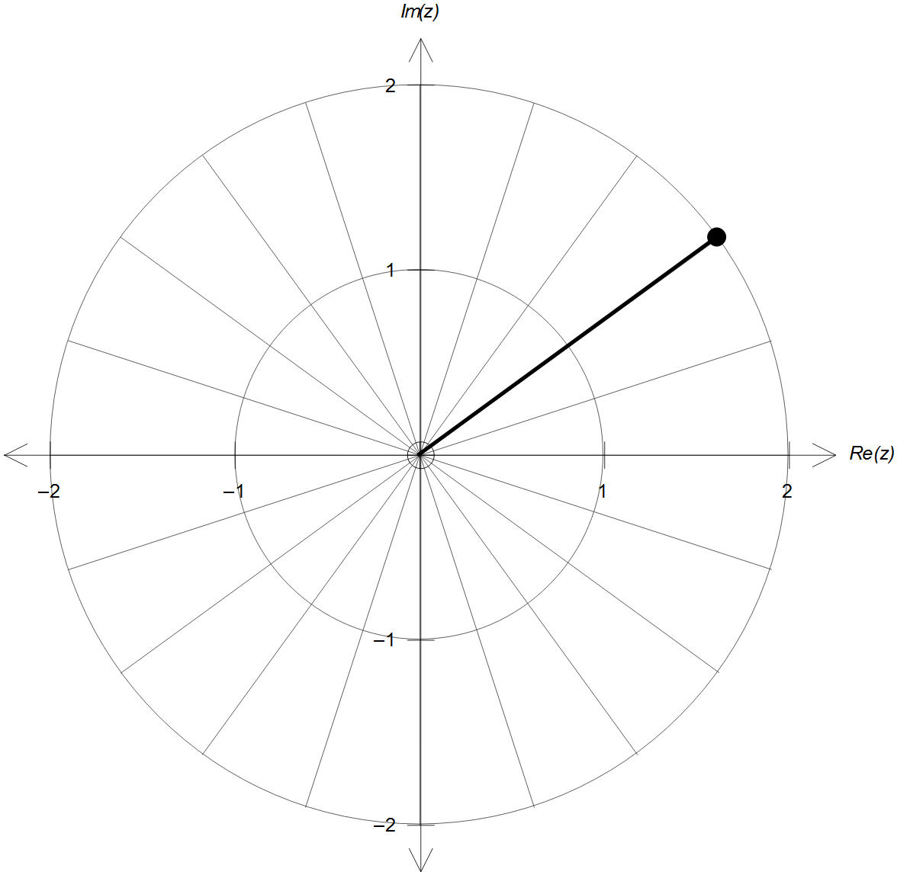

(a) On the same diagram sketch the other solutionsto the equation .

(b) Determine the value of *a* and *b*.

(c) Hence, or otherwise, state all the solutions to the equation  in the

format 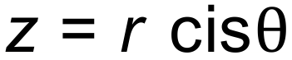.

|  |  |  |  |
| --- | --- | --- | --- |
|  | |  |  | | --- | --- | | EGC_Black | **Eastern Goldfields College**  ***Year 12 MATHEMATICS SPECIALIST***  ***TEST 2 2017***  ***Calculator Assumed*** | |

**Total Marks:17**

**Reading: 2 minutes Time Allowed: 20 minutes**

**Question 5 [3, 2 - 5 marks]**

When two complex numbers are multiplied together the result is a geometric action known as a “spin”.

A spin is a rotation combined with an expansion or a contraction.

Consider the complex numbers 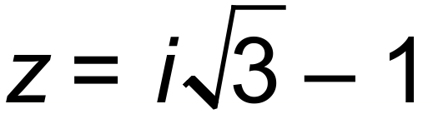 and 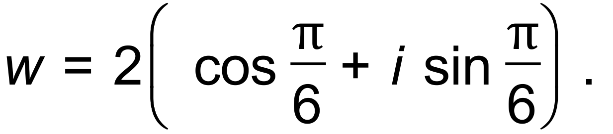

(a) Determine wz in the format 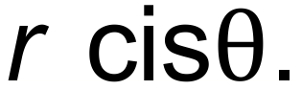

(b) Illustrate the resulting spin by graphing z, w and wz as directed line segments (vectors) in the complex plane given below, clearly labelling your diagram.

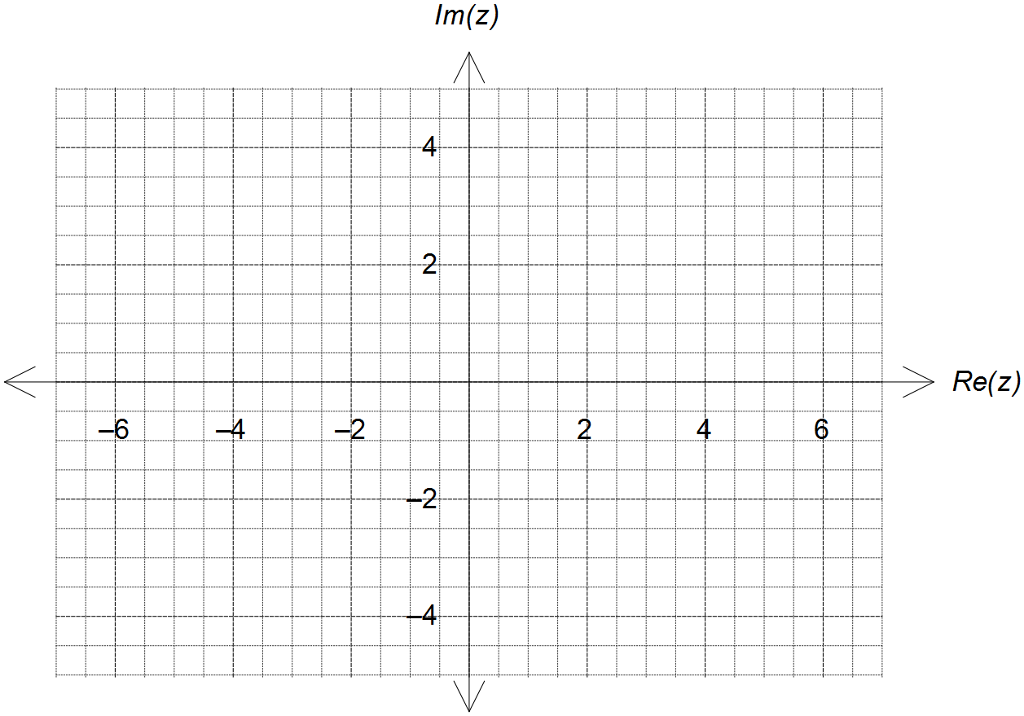

**Question 6 [4, 3 - 7 marks]**

A complex number , is defined by  and .

1. On the polar grid below, graph the sequence  for integers, .

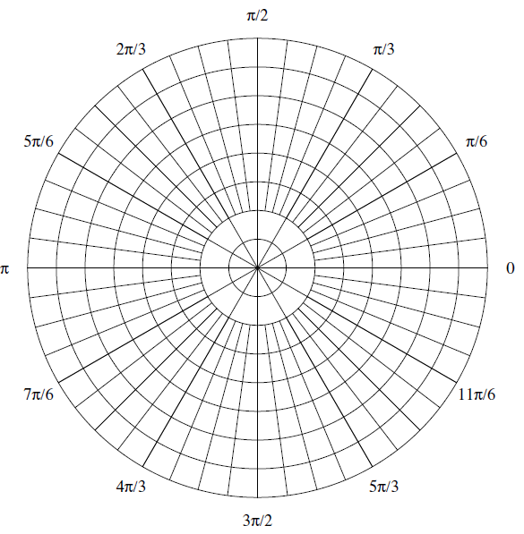

1. Hence or otherwise find the value(s) of *,* where  is an integer  ,

such that  and .

**Question 7 [5 marks]**

Use the expansion of  to show that 